KS2 S.A.T.s

Dear Parents,
This booklet is designed to give you a greater understanding of the format for the Statutory Assessment Tests (SATs) which will take place in May 2024 for Year 6 pupils.
An overview of the tests that the children will take part is shown in the table below and a breakdown of what each test consists of is shown on the pages that follow. We have also included some sample questions and ideas on how you can help.
In the final pages you will also find some information on the assessment and reporting of the data which is generated as a result of the testing. This may help you to gain further insight into how well your child is prepared for the SATs as the year progresses.
As SATs will be upon us before we know it, it would be beneficial to look at the arithmetic homework sent home each week alongside the accompanying revision guide sent home this week. Completing tasks little and often is best and discussion of the questions is important to help understanding. Example SAT reading and grammar and punctuation tasks will be sent home over the next term too. If you have any questions about the content, please do not hesitate to get in touch with me in school.
Thank you, Miss Miller.
Timetable

The KS2 SATs will take place nationally in the week commencing Monday 13th May 2024.
Statutory tests will be administered in the following subjects:
Subject | Timing | Date
Spelling | 15 minutes | Monday 13th May 2024
Grammar and punctuation | 45 minutes | Monday 13th May 2024
Reading | 60 minutes | Tuesday 14th May 2024
Maths Paper 1: Arithmetic | 30 minutes | Wednesday 15th May 2024
Maths Paper 2: Reasoning | 40 minutes | Wednesday 15th May 2024
Maths Paper 3: Reasoning | 40 minutes | Thursday 16th May 2024

All tests are sent away and are externally marked. The results are returned in July, in time to be shared with you in our end of year school reports.
Writing is teacher assessed in school and moderated with other professionals. This means that your child’s class teacher will be able to look at a wide range of your child’s work from their final year in school before making any final judgements in June 2024.
Reading

The reading test is a single paper with questions based on three passages of text. Your child will have one hour, including reading time, to complete the test.
There will be a selection of question types, including:

- Ranking/ordering, e.g. ‘Number the events below to show the order in which they happen in the story’
- Labelling, e.g. ‘Label the text to show the title of the story’
- Find and copy, e.g. ‘Find and copy one word that suggests what the weather is like in the story’
- Short constructed response, e.g. ‘What does the bear eat?’
- Open-ended response, e.g. ‘Look at the sentence that begins Once upon a time. How does the writer increase the tension throughout this paragraph? Explain fully, referring to the text in your answer.’

In 2018 the Department for Education announced that the reading content of the KS2 SATs would be more closely linked to the curriculum in future to ensure children are drawing on their knowledge when answering reading comprehension questions.
What does it look like?
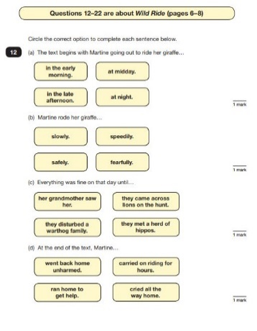
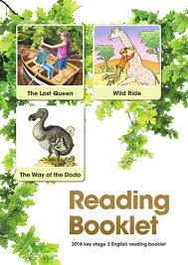
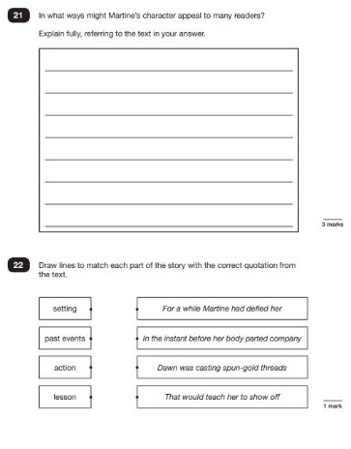

This is what the inside of the answering booklet typically looks like.
This is what the text booklet looks like. It contains three separate texts.

How can I help?
First and foremost, focus on developing an enjoyment and love of reading.
Encourage your child to read lots and read broadly (books, newspapers, magazines, comics, websites etc.). Being a fluent reader really helps to get through the large volume of content in the paper.
Talk to your child about their reading regularly by discussing the plot; what the characters are up to and why; how the words make you feel; what words mean; what might happen next and make sure you follow it up with a ‘why’ questions. Make sure they can justify their ideas using evidence from the text as they will be asked to do this in the test paper.

GPS

Grammar, punctuation and spelling
The grammar, punctuation and spelling test consists of two parts: a grammar and punctuation paper requiring short answers, lasting 45 minutes, and an aural spelling test of 20 words, lasting around 15 minutes.

The grammar and punctuation test will include two sub-types of questions:
- Selected response, e.g. ‘Identify the adjectives in the sentence below’
- Constructed response, e.g. ‘Correct/complete/rewrite the sentence below,’ or, ‘The sentence below has an apostrophe missing. Explain why it needs an apostrophe.’

What do the questions look like?

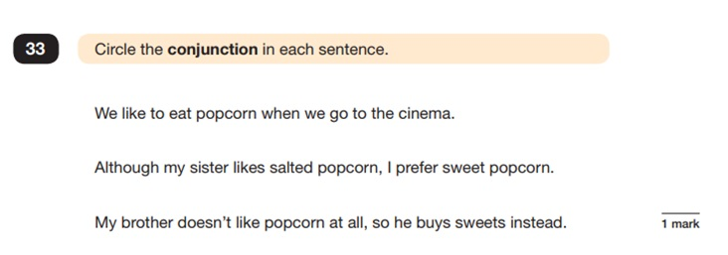
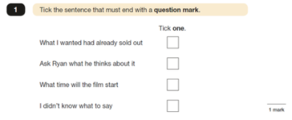

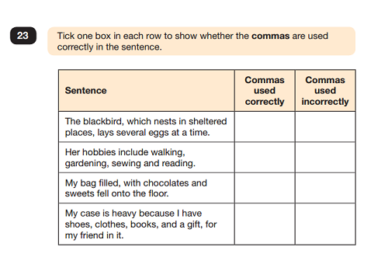

There is also a list of the important spelling words on the next page.

How can I help?
Most of us might feel the need to do a bit of revision on this one!
Support children to identify different word classes and punctation when reading. What piece of punctation is that? What is it used for? Which word is the noun in that sentence?
Encourage your child to spend time learning weekly spellings and make sure that they log on to the Spelling Shed at least once a week. Try using the list on the next page to play games with a pencil and paper e.g. hangman.
To go one step further, you could purchase a study guide produced by publishers such as CGP, Letts and Collins (available at Waterstones or through Amazon) to cover a variety of the concepts covered in the GPS test. Remember…little and often!

How many of these words can you spell?
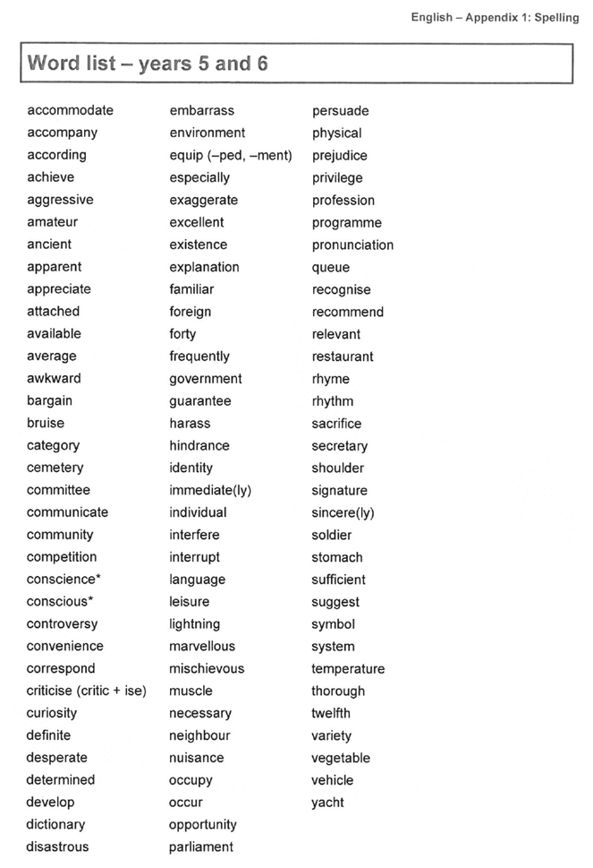

Maths

Children sit three papers in maths:
- Paper 1: arithmetic, 30 minutes
- Papers 2 and 3: reasoning, 40 minutes per paper

Paper 1 will consist of fixed response questions, where children have to give the correct answer to calculations, including long multiplication and division, fractions, decimals and percentages.
Papers 2 and 3 will involve a number of question types, including:
- Multiple choice
- True or false
- Constrained questions, e.g. giving the answer to a calculation, drawing a shape or completing a table or chart
- Less constrained questions, where children will have to explain their approach for solving a problem

Sample questions for the all the papers are available at the back of this booklet. There is also a link to a variety of supportive resources.

What do the questions look like?

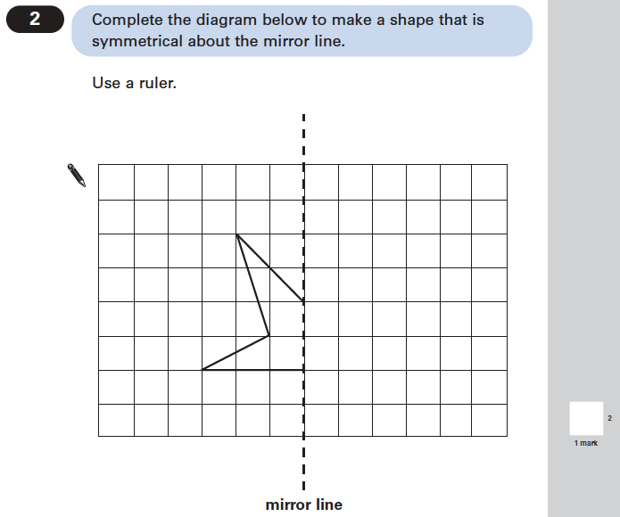
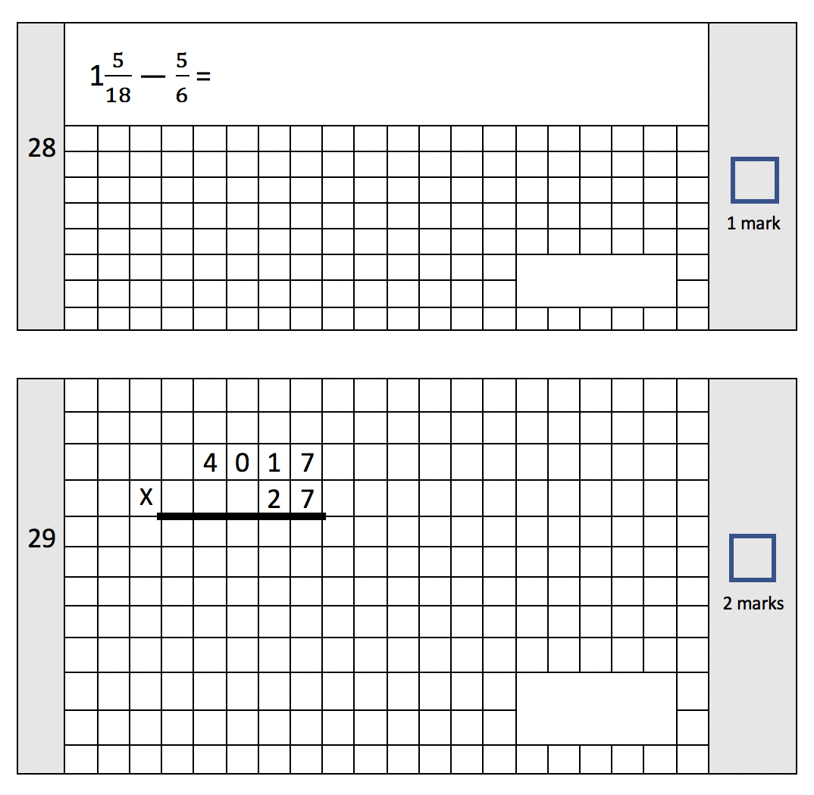
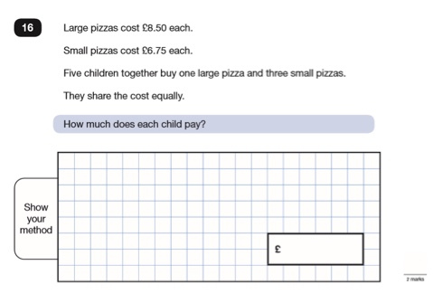

Some questions require the children to draw really accurately with a ruler.
Some questions are presented as problems from every day life.
Example questions from Paper 1.

How can I help?
Play lots of maths games to practise times tables. We provide all children with access to TT Rockstars for this reason but there are also other free games online such as Hit the Button!
Encourage real life maths work by asking good questions e.g. Can you tell me the time? How long is it until your bed time? How much will it all cost? How much change should I get? How many days is it until your birthday?
Identity, weigh and measure quantities in the kitchen for recipes while baking or cooking.
Play games involving numbers and logic e.g. Uno and other card games, Monopoly, dominoes, darts, draughts or chess.
Assessment & Reporting
Once the test papers have been sent off for marking, we wait until early July 2024 for the results.

You will be given your child’s scaled score and whether they have reached the expected standard set by the Department for Education.

The range of scaled scores available for each KS2 test is:
- 80 (the lowest scaled score that can be awarded)
- 120 (the highest scaled score)

The expected standard for each test is a scaled score of 100 or more. If a child is awarded a scaled score of 99 or less they won't have achieved the expected standard in the test.

The Department for Education expects at least 65 per cent of children to reach the expected standard (the figure was initially 85 per cent but has been revised).
What is a scaled scored?
The Scaled Score is worked out from the number of marks the child actually scores in the test. This is known as their RAW score.
The threshold for meeting the expected standard changes slightly each year but the table below gives you some idea of what they were in 2023. The reading and maths thresholds were reduced slightly from the year before as they were deemed more difficult, so it may increase again this year.
At different points in the year, we use past papers to help your child prepare for the testing. We share the results of these in our mid-year reports and for discussion at Parents’ Evening in the Spring term.

 | Reading | SPAG | Maths
Marks to meet the Expected Standard (Scaled Score of 100+) | 24 out of 50  48% | 36 out of 70  51% | 56 out of 110  51%
Marks to meet Greater Depth  (Scaled Score of 110+) | 38 out of 50  76% | 55 out of 70  79% | 94 out of 110  85%
Total Possible Marks | 50 | 70 | 110

The results of the SATs papers are shared with your child’s secondary school in order to support their groupings and organisation for September 2024.
Useful Websites

Website | Useful for…
www.myminimaths.co.uk | Practising Arithmetic Skills in maths. The YouTube videos give good explanation and support.
https://www.topmarks.co.uk/maths-games/hit-the-button | Practising quick recall of times tables.  Who has the highest score in the family?
https://www.cgpbooks.co.uk/resources/ks2-sats-online-10-minute-tests | Useful online mini tests for maths and SPAG.  You can also purchase study guides from this website if you wish.
https://www.satsbootcamp.co.uk/sbc/ | Some parents have subscribed their child to this in the past and found it useful.
https://www.bbc.co.uk/bitesize/primary | Maths and SPAG games and useful explanation videos.
https://whiterosemaths.com/parent-workbooks/ | Printable maths workbooks for home that mirror what we are learning in school closely.
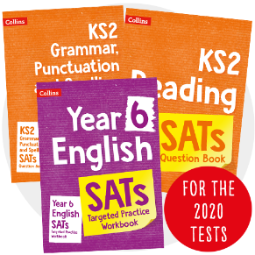 | Not a website but paper-based workbooks designed to support children/parents with SATs practise.
A final word…
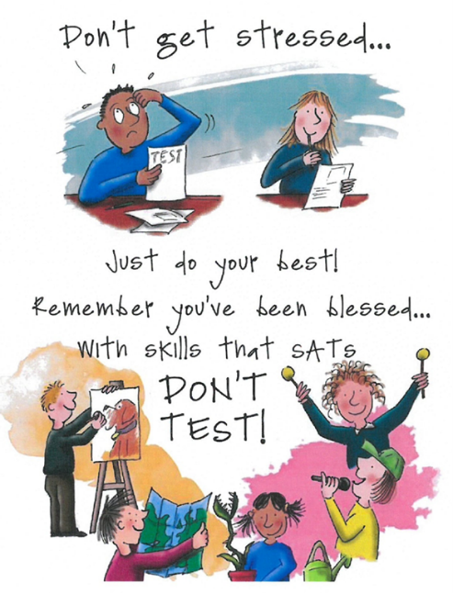

We want all children to feel as confident and optimistic about their final year in Primary School as possible and not worry about SATs or moving on to Secondary school.
However, we do want them to care and take pride in their efforts. We want them to seize the opportunity to work towards a goal, give it their best shot and fulfil their true potential.
We hope that you will support us in making that a reality for them.
Thank you!

