 | Autumn 1 | Autumn 2 | Spring 1 | Spring 2 | Summer 1 | Summer 2
Topic | Where we Live  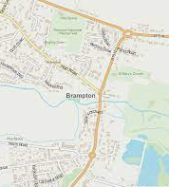 | Night Time  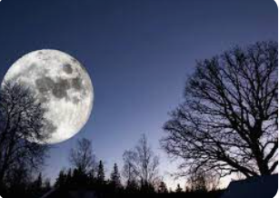 | Whatever The Weather  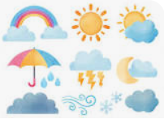 | In The Castle  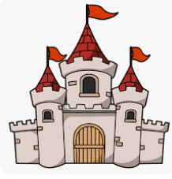 | Amazing Author  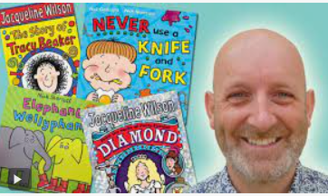 | Animals  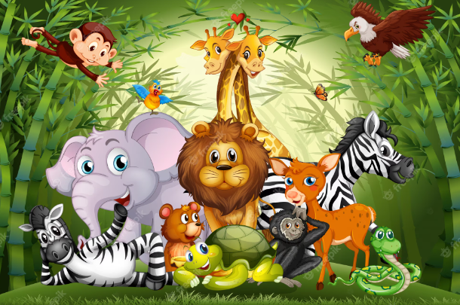
Texts | My mum and dad make me laugh  A Squash and a Squeeze  The Large Family  Six Dinner Sid  The Town Mouse and the Country Mouse  The Three little pigs  The smartest giant in town | Meg And Mog  It Was A Cold Dark Night  Peace at Last  Day Monkey, Night Monkey  Room on the Broom  Lauras Star  Lighting A Lamp | Poetry – Rain  Clouds in the Sky  Jack Frost  How the Wind Blows  The Sun is my Favourite Star | In the Castle  Usborne Beginners: Knights  Sleeping Beauty  Zog  The Princess and the Pea | A Cheese and Tomato Spider / Ketchup on Your Cornflakes  Red Rockets and Rainbow Jelly  Alphabet Ice Cream  Elephant Wellyphant / Moo Cow Kung-Foo Cow  Really Really / Eat your Peas | Non-fiction – looking after a pet  What the Ladybird Heard  Supermarket Zoo  Life in A Pond  Slowly, slowly, slowly said the sloth
Community | Finding out about Brampton, what is here? What is it like to live here? | How our community is different at night, people who work at night | The effect of the weather on the environment | History of the community, the wider community (Carlisle) | Visits from local authors, visits to Carlisle library | Pets at home, animals in the local environment, Talkin Tarn
Opportunities | Trip – Walk around Brampton | Christmas trip to Walby | Trip – Watchtree (windfarm) | Trip – Carlisle Castle | Trip – Carlisle Library | Trip – Lake District Wildlife Park
Understanding the World | Understanding maps, Brampton’s place in the world | Nocturnal animals, why it gets dark, the sun | Different climates, why we get different types of weather | History, changes in the world over time |  | Different habitats
Emotional Awareness | Belonging | Feeling about night time and the dark | Favourite type of weather, the effect of weather on people eg floods | Changes – how would it feel to have lived in Medieval times? | Being an individual | Caring, looking after others

 | Autumn 1 | Autumn 2 | Spring 1 | Spring 2 | Summer 1 | Summer 2
Topic | Where we Live | Colour My World   | Amazing Worlds   | Traditional Tales  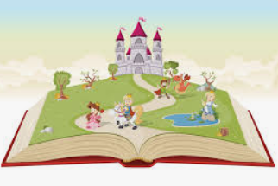 | In the Garden  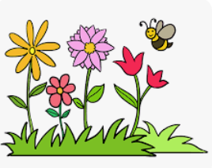 | The Seaside  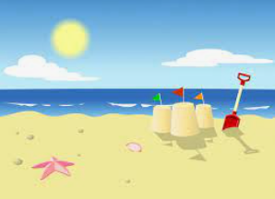
Texts | The Everywhere Bear  My Mum and Dad make Me laugh  The Large Family  A Squash and a Squeeze  Six Dinner Sid  The Town Mouse and the Country Mouse  The Three little Pigs  The Smartest Giant in Town | The Leaf Thief  Bonfire Night – non-fiction  The Day the Crayons Quit  How To Catch A Rainbow  Owl Babies  It Was A Cold Dark Night  Kipper’s Birthday  Elmer  The Colour Monster  Laura’s Star  Christmas Stories | Here We Are  Whatever Next  Slowly, slowly said the sloth  Non-fiction – Deserts  The Ugly Five  The Big Dark | The Gingerbread Man  The Three Billy Goats Gruff  The Elves and the Shoemaker  Snow White  Little Red | Jasper’s Beanstalk  Mad About Minibeasts  To Grow a Flower  Tiny Sees  The Hungry Caterpillar  The Extraordinary Gardner  Stick Man | Billy’s Bucket  The Lighthouse Keeper’s Lunch  Hooray for Fish  Non-fiction – Sharks  Mr Gumpy’s Outing  Brilliant Boats  Commotion In The Ocean
Community | Finding out about Brampton, what is here? What is it like to live here? | Celebrations and festivals | Similarities and differences | Traditions | Parks, allotments, where food comes from | Find out about a seaside town
Opportunities | Trip – walk around Brampton | Walby Farm Park – Christmas experience | Dino World | Visit to Carlisle Library  Visit from storyteller, shoe maker | Watchtree Nature Reserve, Oakbank Nursery, Tarn Road Nursery. Talkin Tarn | Aquarium
Understanding the World | Understanding maps, Brampton’s place in the world | Why do we celebrate? | Different parts of the world, how people live differently, different animals and environments | History, linked to the stories | Why gardens are important, bees etc, living and growing | Coasts, land, sea, tides, sea-life, the impact of fishing etc, food chains
Emotional Awareness | Belonging | Differences, feelings |  | Linked to each story | Looking after living things

